Дата: 18.12.2020.
Группа: 20 ПСО-1ДК
Наименование дисциплины: Английский язык

Тема: Спорт

SPORT IN GREAT BRITAIN

Many kinds of sport originated from England. The English have a proverb, “All work and no play makes Jack a dull boy”. They do not think that play is more important than work; they think that Jack will do his work better if he plays as well, so he is encourages to do both. Association football, or soccer is one of the most popular games in the British Isles played from late August until the beginning of May. In summer the English national sport is cricket. When the English say: “that’s not cricket” it means “that’s not fair”, “to play the games” means “to be fair”.
Golf is Scotland’s chief contribution to British sport. It is worth nothing here an interesting feature of sporting life in Britain, namely, its frequently close connection with the social class of the players or spectators except where a game may be said to be a “national” sport. This is the case with cricket in England which is played and watched by all classes. This is true of golf, which is everywhere in the British Isles a middle-class activity. Rugby Union, the amateur variety of Rugby football, is the Welsh national sport played by all sections of society whereas, elsewhere, it too is a game for the middle classes. Association football is a working-class sport as are boxing, wrestling, snooker, darts and dog-racing. As far as fishing is concerned it is, apart from being the most popular British sport from the angle of the number of active participants, a sport where what is caught determines the class of a fisherman. If it is a salmon or trout it is upper-class, but if it is the sort of fish found in canals, ponds or the sea, then the angler is almost sure to be working-class.
Walking and swimming are the two most popular sporting activities, being almost equally undertaken by men and women. Snooker (billiards), pool and darts are next most popular sports among men. Aerobics (keep-fit exercises) and yoga, squash and cycling are among the sports where participation has been increasing in recent years.
There are several places in Britain associated with a particular kind of sport. One of them is Wimbledon – a suburb to the south of London where the All-England Lawn Tennis Championships are held in July (since 1877). The finals of the tournament are played on the Centre Court. The other one is Wembley – a stadium in north London where international football matches, the Cup Finals and other events have taken place since 1923. It can hold over 100000 spectators. The third one is Derby, the most famous flat race in the English racing calendar, which has been run at Epsom near London since 1780.

Контрольные задания

- Find the names of sports in the crossword.
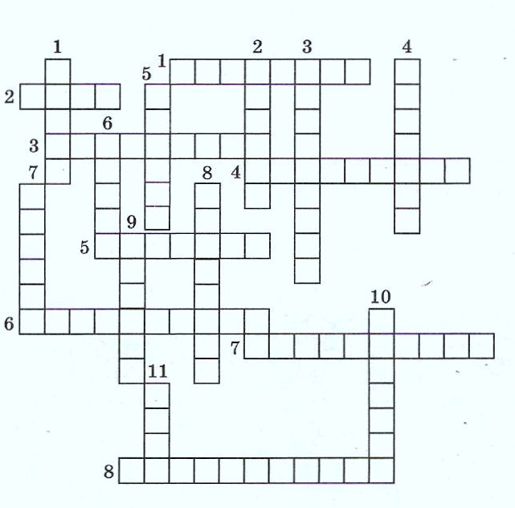
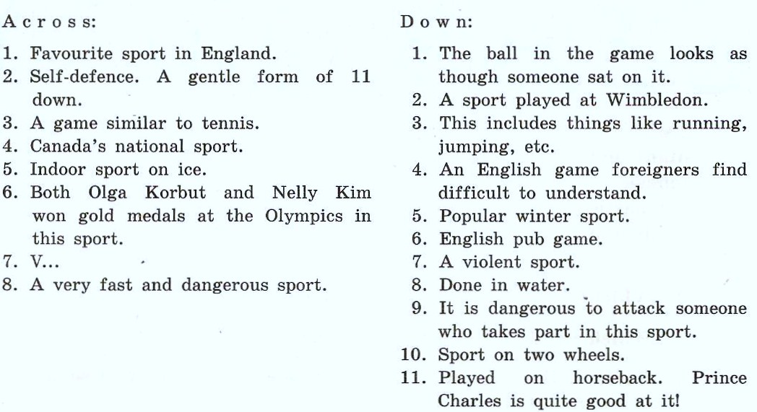

- What kind of sport?

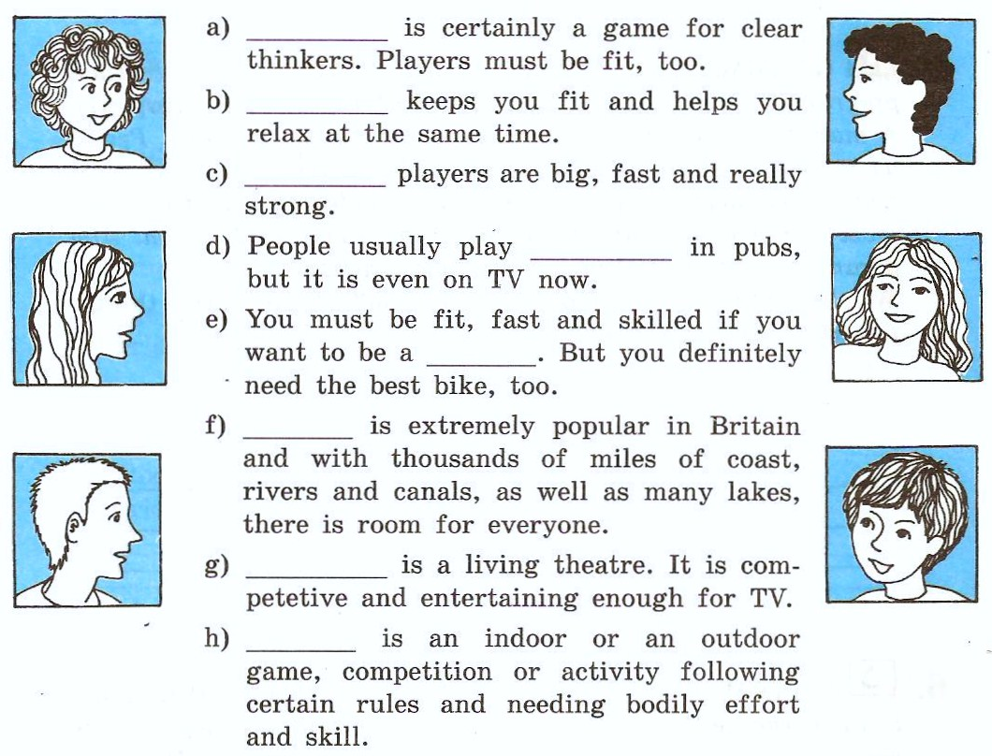

- Choose the right word to complete these opinions.

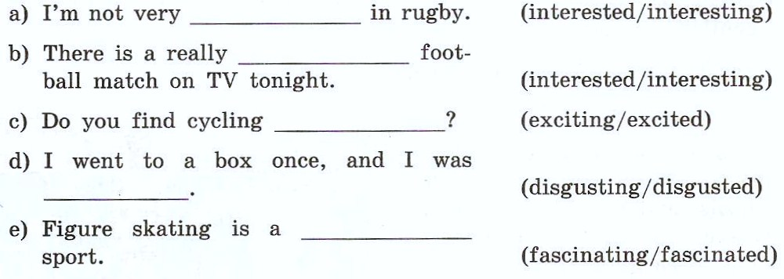

- Match the names of sports with the names of equipments.
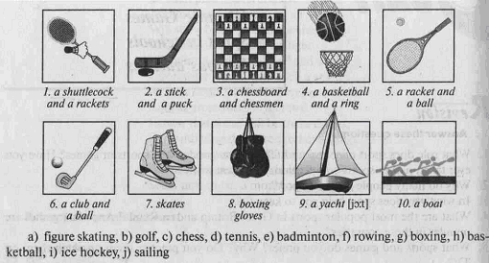

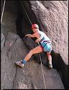
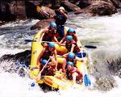
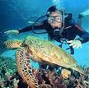
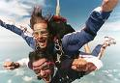
- Match the pictures to the names of sport
a) sky diving
b) bungee jumping
c) pot holing
d) rock climbing
e) white-water rafting
f) scuba diving
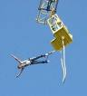

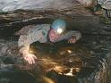

- Fill in the information with the right forms of the verbs.

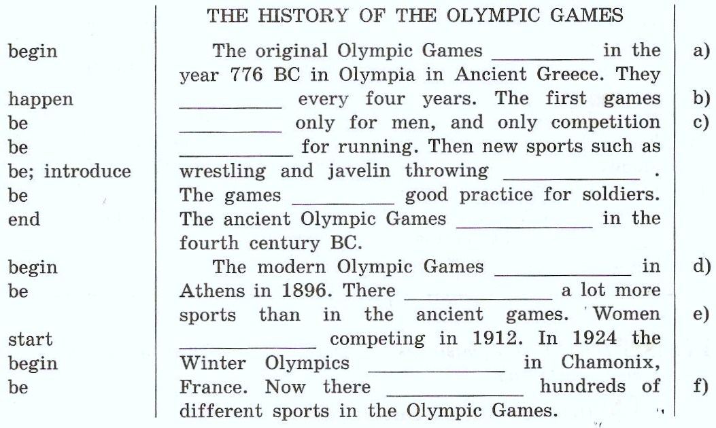
Complete the questions to the facts about the Olympic Games.
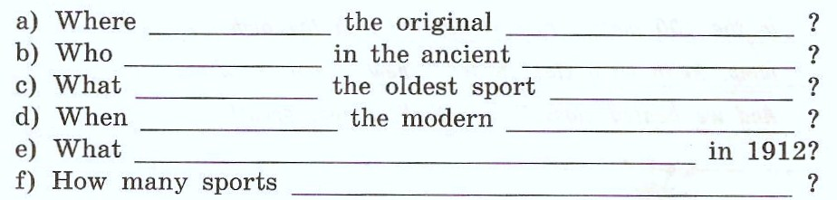

Преподаватель М.М. Джаутханова

