Дата: 16.12.2020.
Группа: 20 ИСиП-1ДК
Наименование дисциплины: Английский язык

Тема: Спорт

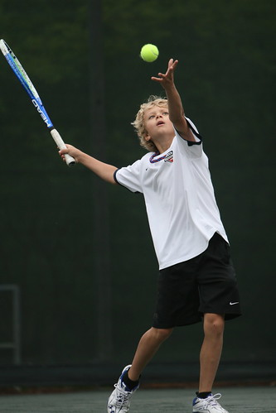

Sport in my life.
Sport is very important in our life. The general belief is that a person who goes in for sports can’t be weak and ill. Physically inactive people get old earlier that those, who find time for sport activity. And of course good health is better than good medicine.
People all over the world are fond of sports and games. In our country sport is being widely popularized as well. The most popular kinds of sport are football, volleyball, basketball, tennis, figure-skating, aerobics, ping-pong and swimming. A lot of people are fond of jogging. In schools and colleges sport is a compulsory subject. Many young people attend sport sections. Some of them dream to become professional sportsmen.
As for me, I can’t imagine my life without sport. In summer I go jogging every morning and when I have free time I attend swimming pool. In winter I like to skate with my friends. It’s fun. Also I’m fond of aerobics. First of all aerobics helps to keep myself fit. It also attracts me because it resembles dancing.
In conclusion I’d like to say that I’m absolutely sure that doing sports is the best way to keep fit. Sport makes our bodies strong, it prevents us from getting too fat, and makes us more self-organized and better disciplined.

- belief – вера, мнение, убеждение
- to go in for sports, to do sports – заниматься спортом
- inactive – бездеятельный, малоподвижный
- activity – деятельность
- good health – крепкое здоровье
- fond of – любить (что-то делать)
- jogging – бег трусцой
- compulsory – обязательный
- to skate – кататься, бегать на коньках
- to resemble – быть похожим, иметь сходство
- to keep fit – поддерживать в форме
- to prevent – препятствовать
- to get fat – растолстеть, потолстеть

Контрольные задания

Exercises
- Word power. Many sport words became international. Do you know these sport words? Put the words in the right column in the table.

swimming
ball
athlete
hockey
ride
field
mountaineer
fast
chess
swim
tennis player
artistic
skiing
track
gymnastics
patient
play
do
parachute
net
figure skater
footballer
box
energetic
gymnast
bike
go
courageous
acrobat
ring
golf
figure skating
cricket
skate
windsurfing
horse-racing
cycling
acrobatics
parachutist
bold
judo
badminton
pool
strong
basketball
stadium
jump
runner

sport
sportsman
equipment
activity
skills

- Вставьте пропущенные буквы в слова.

acti_ity
s_ort
sk_ing
r_gby
s_ort_man
ma_ch
sw_mming p_ol
_udo
dan_erous
com_eti_ion
bod_bu_lding
f_tness
m_dal

- Распутайте слова.

doortuo megas
treexem
dlog daemsl
lccynig
netnsi
nasmygcits
arrehcy
kcircte
sucsid
cohyke
smwmniig
layp
pujm
toolfabl

- Match the words with the pictures.
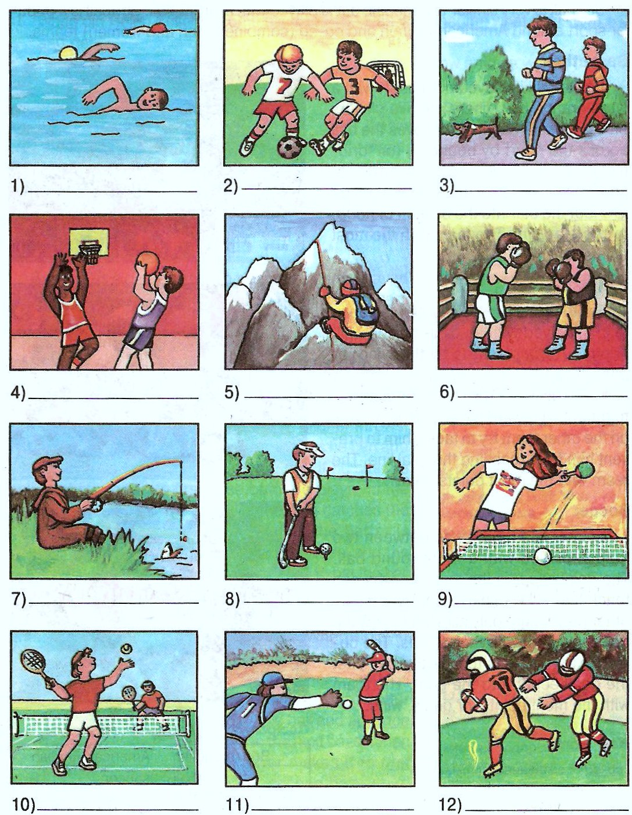

basketball
boxing
fishing
football
golf
jogging
baseball
swimming
table tennis / ping-pong
tennis
soccer
mountain climbing

Преподаватель М.М. Джаутханова

