Дата: 15.12.2020.
Группа: 20 ПСО-1ДК
Наименование дисциплины: Английский язык

Тема: Спорт

SPORT IN GREAT BRITAIN

Many kinds of sport originated from England. The English have a proverb, “All work and no play makes Jack a dull boy”. They do not think that play is more important than work; they think that Jack will do his work better if he plays as well, so he is encourages to do both. Association football, or soccer is one of the most popular games in the British Isles played from late August until the beginning of May. In summer the English national sport is cricket. When the English say: “that’s not cricket” it means “that’s not fair”, “to play the games” means “to be fair”.
Golf is Scotland’s chief contribution to British sport. It is worth nothing here an interesting feature of sporting life in Britain, namely, its frequently close connection with the social class of the players or spectators except where a game may be said to be a “national” sport. This is the case with cricket in England which is played and watched by all classes. This is true of golf, which is everywhere in the British Isles a middle-class activity. Rugby Union, the amateur variety of Rugby football, is the Welsh national sport played by all sections of society whereas, elsewhere, it too is a game for the middle classes. Association football is a working-class sport as are boxing, wrestling, snooker, darts and dog-racing. As far as fishing is concerned it is, apart from being the most popular British sport from the angle of the number of active participants, a sport where what is caught determines the class of a fisherman. If it is a salmon or trout it is upper-class, but if it is the sort of fish found in canals, ponds or the sea, then the angler is almost sure to be working-class.
Walking and swimming are the two most popular sporting activities, being almost equally undertaken by men and women. Snooker (billiards), pool and darts are next most popular sports among men. Aerobics (keep-fit exercises) and yoga, squash and cycling are among the sports where participation has been increasing in recent years.
There are several places in Britain associated with a particular kind of sport. One of them is Wimbledon – a suburb to the south of London where the All-England Lawn Tennis Championships are held in July (since 1877). The finals of the tournament are played on the Centre Court. The other one is Wembley – a stadium in north London where international football matches, the Cup Finals and other events have taken place since 1923. It can hold over 100000 spectators. The third one is Derby, the most famous flat race in the English racing calendar, which has been run at Epsom near London since 1780.

Vocabulary

acrobat – акробат
acrobatics – акробатика
activity – деятельность
aerobics – аэробика
amateur – любитель, поклонник
angler – рыбак
archery – стрельба из лука
artistic – артистичный
aspirin – аспирин
athlete – легкоатлет
athletics – атлетика
attack – атаковать
badminton – бадминтон
ball – мяч
basketball - баскетбол
bike – велосипед
boat – лодка
bodybuilding – бодибилдинг
bold – отважный
box – бокс
boxing – бокс
boxing gloves – боксерские перчатки
canals – каналы
championship – чемпионат
chess – шахматы
chessboard – шахматная доска
chessmen – шахматная фигура
club – дубинка
coast – морское побережье
competition – соревнование
contribution – взнос, пожертвование
courageous – мужественный
cricket – крикет
cycling – езда на велосипеде
dangerous – опасный
darts - дротики
definitely – точно, определенно
determine – определять
discus – диск
do – делать
dog-racing – гонки собак
effort – усилие, попытка
encourage – ободрять
energetic – энергичный
entertaining – забавный
extreme – экстрим
fast – быстрый
fast spin – быстрое вращение
field – поле
figure skater – фигурист
figure skating – фигурное катание
fishing – рыбалка
fitness – фитнес
football – футбол
footballer – футболист
foreigners – иностранец
gentle form – знатный вид
go – идти
gold medals – золотые медали
golf – гольф
Greece – Греция
gymnast – гимнаст
gymnastics – гимнастика
hockey – хоккей
horseback – верхом
horse-racing – гонка лошадей
include – содержать
indoor – находящиеся в помещении
Javelin throwing – метание копьем
jogging – бег трусцой
judo – дзюдо
jump – прыгать
karate - каратэ
kilt – килт
lakes – озера
Marvelous – изумительный
match – матч
medal – медаль
motor racing – мотогонки
mountain climbing – скалолазание
mountaineer – альпинист
net – сетка
Olympic Games – Олимпийские игры
originate – создавать, порождать
outdoor games – игры на открытом воздухе
parachute – парашют
parachutist – парашютист
participation – участие
patient – терпеливый
pimpled rubber – прыщеватая резина
ping-pong – настольный теннис
pipe – трубка
play – играть
polo – поло
pool – лужа, прудок
proverb – пословица
pub – пивная
puck – шайба
racket – ракетка
recent – недавний
record – рекорд
ride – ездить верхом
ring – кольцо
rowing – гребля
rugby – регби
runner – бегун
sailing – мореплавание
scuba diving – ныряние аквалангом
self-defence – самозащита
shuttlecock – волан
skate – кататься на коньках
skates – коньки
skiing – катание на лыжах
skill – умение
sky diving – прыжки с высоты
bungee jumping – прыжки с веревкой
pot holing – спуск в пещеры
rock climbing - скалолазание
snooker – снукер
soccer – футбол
Soldiers – солдаты
spectators – наблюдатели
sportsman – спортсмен
squash – сжимать
stadium – стадион
stick – бита
strong – сильный
suburb – окраина
swim – плавать
swimming – плавание
swimming pool – бассейн
tennis – теннис
tennis player – игрок тенниса
thinker – мыслитель
throwing the hammer – бросание молота
tossing the caber – бросание прута
tournament – турнир
track – след
tug of war – перетягивание каната
wheels – колеса
white-water rafting – сплав
windsurfing – виндсерфинг
wooden – деревянный
working-class – рабочий класс
Wrestling – борьба
yacht – яхта
yoga – йога

Контрольные задания

- Sequencing.
Put the points of the plan in the correct order.
- Places in Great Britain associated with particular kinds of sport.
- All work and no play makes Jack a dull boy.
- Connection of sport life with social class of players and spectators.
- Popular kinds of sport.
- National kinds of sport.

- Multiple choice.
Choose the correct variant.
- “all work and no play makes Jack a dull boy” means:
- We must work but not play;
- Play is more important than work;
- We should do both: play and work.
Why do they think so?
- The phrase “to play the game” means:
- To be sly, pretend;
- To be honest, fair;
- To be active, energetic.

- Filling the gaps.
Put in the necessary words or phrases to complete the sentences.
- Association football is played from … till … .
- Cricket is … national sport.
- The Scotland’s chief contribution to British sport is … .
- Rugby Union, the amateur variety of rugby football is … national game.
- Fishermen of upper-class catch … , anglers of working class catch ordinary fish in … .

- Matching.
Match the beginning of the phrase with the suitable ending.

- International football matches (like the Cup Final and others) take place in … .
- Wembley (a stadium in North London);
- All-England Lawn Tennis Championship are held in July in … .
- Derby at Epson;
- The most famous flat race is … .
- Wimbledon (a suburb to the South of London).

- Match the pictures with the words given in the list:

- Tossing the caber;
- Throwing the hammer;
- Traditional music of pipes (pipers);
- Tug of war;
- Dancing competitions (Highland fling, sword dance);
- Athletes in kilts.

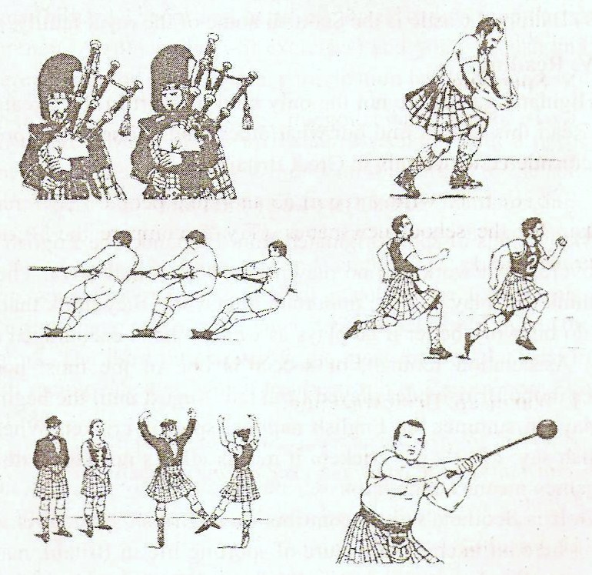

Преподаватель М.М. Джаутханова

